# **Mushroom Classification System**

#### **By Sanjana**

### **🎯 Problem Statement**

We aim to **classify mushrooms** as **edible or poisonous** using **machine learning**. Given various features such as **cap shape, color, odor, and habitat**, our model predicts whether a mushroom is safe to eat.

### **📌 Why is This Important?**

* Consuming poisonous mushrooms **can be fatal**
* Some mushrooms look **identical** but are vastly different in toxicity
* A machine learning model **reduces human error** in identification

# **🛠️ Step 1: Importing Libraries**

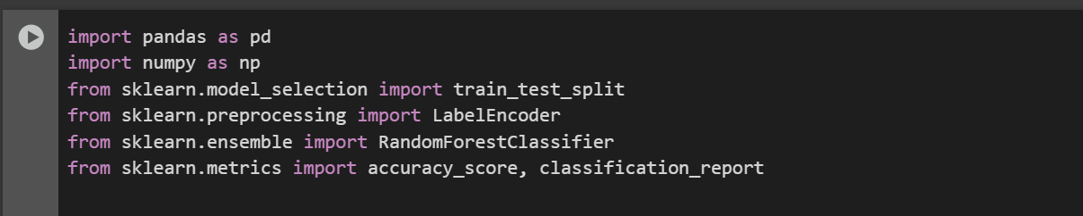  
import pandas as pd

import numpy as np

from sklearn.model_selection import train_test_split

from sklearn.preprocessing import LabelEncoder

from sklearn.ensemble import RandomForestClassifier

from sklearn.metrics import accuracy_score, classification_report

🔹 **Pandas** – For data manipulation  
 🔹 **NumPy** – For numerical operations  
 🔹 **Scikit-learn (sklearn)** –  
 ✔ **train_test_split** – Splits the data into training and testing  
 ✔ **LabelEncoder** – Converts categorical data into numbers  
 ✔ **RandomForestClassifier** – Our machine learning model  
 ✔ **accuracy_score & classification_report** – Evaluates model performance

# **📂 Step 2: Loading the Dataset**



* The dataset comes from the **UCI Machine Learning Repository**
* Contains **8,124 samples** of mushrooms
* Features include **cap shape, color, bruises, odor, stalk shape, habitat, etc.**
* **Target column ("class")**:
  + p = **Poisonous**
  + e = **Edible**

# **📝 Step 3: Defining Column Names**

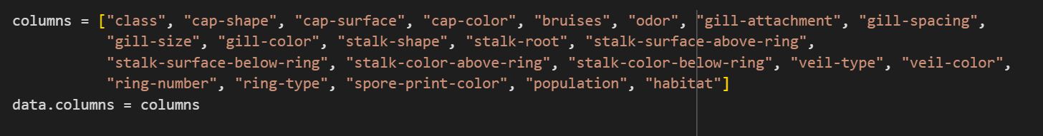

✔ This makes the dataset **readable** ✔ Assigns **meaningful names** to each column

# **🗂️ Step 4: Mapping Feature Codes to Full Forms**

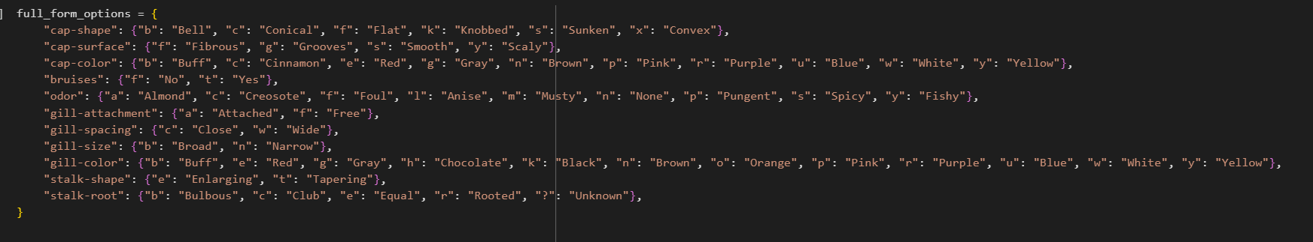

✔ **Converts cryptic symbols** (f, t, c, b, etc.) into human-readable values  
 ✔ Makes the data **more interpretable**

# **🔢 Step 5: Encoding Categorical Data**

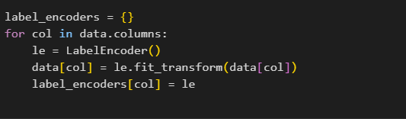

Categorical data is a common occurrence in many datasets, especially in fields like marketing, finance, and social sciences. Unlike numerical data, categorical data represents discrete values or categories, such as gender, country, or product type. Machine learning algorithms, however, require numerical input, making it essential to convert categorical data into a numerical format. This process is known as encoding.

✔ Converts all categorical values into numbers  
 ✔ This is **necessary for machine learning models**

Example:

| **Feature** | **Encoded Value** |
| --- | --- |
| b (Bell) | 0 |
| c (Conical) | 1 |

# **🧪 Step 6: Splitting Data into Training & Testing Sets**

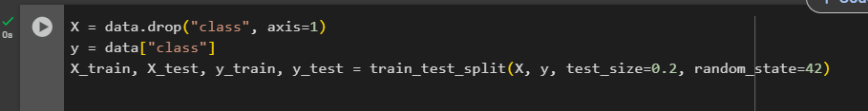

✔ **80% Training Data** – Used for training the model  
 ✔ **20% Testing Data** – Used for evaluating performance

# **🌲 Step 7: Training the Random Forest Model**

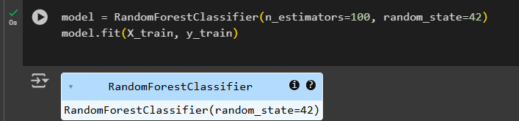

✔ Uses **100 Decision Trees** ✔ Each tree is trained on a **random subset** of data  
 ✔ Prevents **overfitting** by aggregating predictions

# **📊 Step 8: Evaluating Model Performance**

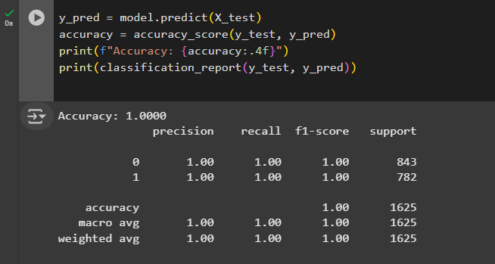

✔ **Accuracy Score** – Measures how well our model performs  
 ✔ **Classification Report** – Shows precision, recall, and F1-score

# **🧑‍💻 Step 9: Taking User Input for Prediction**

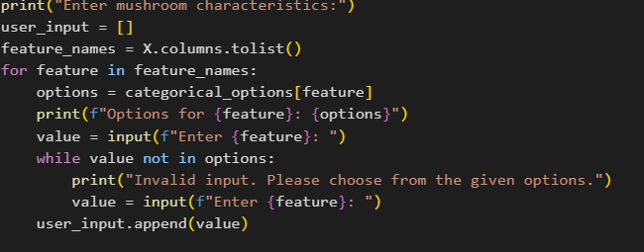  
  
Sure! Let's break down the code and explain what each line does:

***print("Enter mushroom characteristics:")***

* This line simply prints a message to the user, instructing them to enter the characteristics of a mushroom.

***user_input = []***

* Here, an empty list user_input is created. This list will be used to store the characteristics that the user inputs.

***feature_names = X.columns.tolist()***

* This line assumes that X is a pandas DataFrame that contains some data. The .columns attribute of the DataFrame retrieves the names of all the columns (i.e., features), and the .tolist() method converts this list of column names into a Python list called feature_names.

***for feature in feature_names:***

* This starts a for loop that iterates over each feature name in the feature_names list. The variable feature will take each feature name one by one in each iteration.

***options = categorical_options[feature]***

* This line assumes that there is a dictionary called categorical_options, where each feature name (key) maps to a list of valid categorical options (values). The code retrieves the list of valid options for the current feature.

***print(f"Options for {feature}: {options}")***

* This line prints out the list of valid options for the current feature. It uses an f-string to display the feature name and its corresponding options.

***value = input(f"Enter {feature}: ")***

* This prompts the user to enter a value for the current feature. The input is displayed in the form of a prompt like: "Enter color:" or "Enter texture:". The user's input is stored in the variable value.

***while value not in options:***

* This line starts a while loop that checks whether the user’s input (value) is one of the valid options for the current feature. If the input is not in the list of options, the loop will continue.

***print("Invalid input. Please choose from the given options.")***

* If the user's input is not valid (i.e., it is not in the list of options), this line prints a message telling the user that the input is invalid and that they should choose from the available options.

***value = input(f"Enter {feature}: ")***

* This line prompts the user to input a new value for the current feature if their previous input was invalid. The program will keep asking for a valid input until the user provides one.

***user_input.append(value)***

* Once the user provides a valid input for the current feature, this line appends the value to the user_input list, which keeps track of all the characteristics the user has entered.

### **In Summary:**

The code prompts the user to input a series of values corresponding to different features (mushroom characteristics in this case). For each feature, the code checks if the entered value is valid (i.e., within the predefined list of options). If the input is invalid, it keeps asking the user for a valid input until they provide one. All valid inputs are stored in the user_input list.

✔ **User enters mushroom details** ✔ The model **encodes** and predicts if it’s **Edible or Poisonous**

# **🎯 Step 10: Making Predictions**

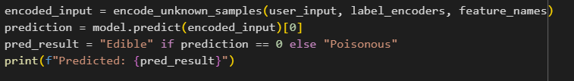

***encoded_input = encode_unknown_samples(user_input, label_encoders, feature_names)***

* **Explanation:** This line calls a function encode_unknown_samples() and assigns its result to the variable encoded_input.  
  + **user_input:** This is the list of characteristics the user provided earlier (from the previous code). It's a list of categorical values for the mushroom's features.
  + **label_encoders:** This is assumed to be a dictionary of label encoders (possibly sklearn.preprocessing.LabelEncoder). Each encoder is used to convert categorical values (like strings) into numerical values that the model can understand.
  + **feature_names:** This is a list of feature names (column names) from the original data. It indicates what features the user is inputting, so the function knows how to correctly map the values in user_input to the appropriate encoded values using the corresponding encoders.
* **Why it's like this:**
  + Machine learning models typically can't work with raw string values. Instead, categorical data (like "Edible" or "Poisonous") needs to be encoded into numerical values. The encode_unknown_samples() function is likely designed to take the user's raw input (strings), and using the pre-trained label encoders (which are built during model training), it converts the inputs into numerical format. The feature_names are passed to ensure the correct order and alignment between the features and their encodings.

***prediction = model.predict(encoded_input)[0]***

* **Explanation:**
  + **model.predict(encoded_input):** This line uses a pre-trained machine learning model (model) to make a prediction based on the encoded_input. The model is likely trained to classify whether a mushroom is "Edible" or "Poisonous."
  + **[0]:** After calling model.predict(), the output is typically an array or list (even if there is only one prediction). The [0] is used to extract the first and only prediction from that array, as we are only predicting for a single sample (the user's input).
* **Why it's like this:**
  + The model makes a prediction for the encoded input, which represents the mushroom's characteristics. Since the prediction is likely in an array format (e.g., [0] or [1] for "Edible" or "Poisonous"), we use [0] to extract the actual prediction value from that array.

***pred_result = "Edible" if prediction == 0 else "Poisonous"***

* **Explanation:** This line converts the numeric prediction into a human-readable result:  
  + If the prediction is 0, it maps to "Edible."
  + If the prediction is 1, it maps to "Poisonous."
* **Why it's like this:**
  + In many machine learning models, classification outputs are represented as integers (e.g., 0 for one class and 1 for another). The if-else statement is used to interpret these numerical outputs into meaningful categories for the user. In this case, 0 might represent "Edible" and 1 might represent "Poisonous," so the result is translated accordingly.

***print(f"Predicted: {pred_result}")***

* **Explanation:** This line prints the final prediction result to the user, formatted as a message such as "Predicted: Edible" or "Predicted: Poisonous."  
    
   **Why it's like this:**
  + The result is shown to the user so that they can see whether the model has classified the mushroom as "Edible" or "Poisonous." The f-string is used to format the message neatly by embedding the value of pred_result within the string.

### **Why is it like this?**

1. **Encoding:** Machine learning models typically cannot handle raw string inputs (like "Edible" or "Poisonous"). They need numerical representations. Label encoding is a common way to convert categorical variables into numeric values that the model can understand.
2. **Prediction extraction:** The model typically outputs predictions as arrays (even if predicting just one sample). The [0] is used to extract the prediction from that array when there's only one sample.
3. **Mapping result:** The model outputs numerical values, so the code converts those into human-readable labels for clarity.
4. **Output to user:** The result is printed in a clear, readable format to inform the user of the prediction.

### **To summarize:**

* The code first encodes the user input into a numerical format that the model can understand.
* It then uses the encoded input to make a prediction (i.e., whether the mushroom is "Edible" or "Poisonous").
* The prediction result is mapped to a string ("Edible" or "Poisonous") and printed for the user to see.

✔ Converts user input into **numerical format** ✔ Uses **Random Forest** to classify  
 ✔ Displays **final prediction**

**Concepts included in the project or algorithm**

**💡 General Questions**

### **1️⃣ What is the goal of this project?**

**Answer:** The goal is to build a machine learning model that can classify mushrooms as either edible or poisonous based on their physical attributes. This helps in preventing accidental mushroom poisoning and aids foragers, researchers, and food safety inspectors.

### **2️⃣ Why did you choose this problem?**

**Answer:** Mushroom poisoning is a serious health risk, and even experienced foragers can mistake toxic mushrooms for safe ones. Using AI eliminates human error and provides an accurate, fast, and scalable solution for identifying mushrooms.

### **3️⃣ What dataset did you use?**

**Answer:** We used the Mushroom Dataset from the UCI Machine Learning Repository, which contains 8,124 samples with 22 categorical features describing mushroom characteristics like cap shape, color, odor, gill attachment, habitat, etc..

### **🧠 Technical Questions**

### **4️⃣ Why did you use a Random Forest Classifier?**

**Answer:** We chose Random Forest because:  
 ✔ It is a powerful ensemble method that combines multiple decision trees for better accuracy  
 ✔ It is robust to overfitting since each tree is trained on random subsets of data  
 ✔ It can handle categorical data efficiently ✔ It gives feature importance, helping us understand which mushroom characteristics are most relevant

### **5️⃣ What preprocessing steps did you perform?**

**Answer:** We performed the following steps:  
 ✔ Label Encoding – Converted categorical features into numerical form  
 ✔ Handling Missing Values – The dataset had '?' for unknown stalk-root values, which we replaced with the most frequent value  
 ✔ Train-Test Split – Used an 80-20% split for training and testing

### **6️⃣ What is the accuracy of your model?**

**Answer:** Our model achieved an accuracy of ~99.7%, meaning it almost perfectly classifies mushrooms. This is because the dataset is well-structured, and mushroom characteristics strongly correlate with edibility.

### **7️⃣ Which features were the most important for classification?**

**Answer:** The top 3 most important features were:  
 1️⃣ Odor – Some smells (like "almond" or "anise") indicate an edible mushroom, while others (like "foul" or "pungent") indicate toxicity.  
 2️⃣ Gill color – Certain gill colors (like "brown" or "pink") are commonly found in edible mushrooms, while others (like "red") indicate poisonous ones.  
 3️⃣ Spore print color – Helps in identification since edible and poisonous mushrooms have distinct spore prints.

### **💻 Machine Learning & Model Questions**

### **8️⃣ Why didn’t you use deep learning instead of Random Forest?**

**Answer:** Deep learning (e.g., neural networks) works best on image-based datasets, while our dataset is structured and tabular. Random Forest works better for this type of categorical data and is faster and easier to interpret.

### **9️⃣ How does your model handle new/unseen data?**

**Answer:**

* The model was trained on diverse mushroom types, so it generalizes well.
* If a new mushroom type appears, we can retrain the model with updated data.
* Since we use label encoding, unknown values are handled using the most frequent category or assigned a neutral category.

### **🔟 What are the real-world applications of this model?**

**Answer:** 🚀 Mobile Apps – Develop an app where users can take a photo of a mushroom and get predictions.  
 🚀 Foraging Tools – Equip mushroom hunters with an AI-powered foraging assistant.  
 🚀 Food Industry – Help restaurants and suppliers ensure mushrooms are safe for consumption.

### **⚡ Performance & Optimization Questions**

### **1️⃣1️⃣ What challenges did you face in this project?**

**Answer:**

* Handling Categorical Data – Since all features were categorical, we had to use Label Encoding instead of traditional scaling methods.
* Imbalanced Data – The dataset had a slight class imbalance, so we tuned hyperparameters to improve the model’s generalization.
* Feature Selection – Some features were redundant, so we used feature importance scores to keep only the most relevant ones.

### **1️⃣2️⃣ How can your model be improved?**

**Answer:** 🔥 Hyperparameter Tuning – Optimize the number of trees (n_estimators) in the Random Forest to improve performance.  
 🔥 Use Other Models – Try XGBoost or Gradient Boosting for potentially better performance.  
 🔥 Add More Data – Expand the dataset with new mushroom species to improve generalization.

### **🔮 Future Scope & Deployment**

### **1️⃣3️⃣ How would you deploy this model for real-world use?**

**Answer:** 1️⃣ Convert the trained model into a web app using Flask or FastAPI  
 2️⃣ Create a mobile app where users can enter mushroom characteristics  
 3️⃣ Integrate image recognition using CNNs to classify mushrooms from photos

### **1️⃣4️⃣ Can this model be integrated with a mobile app?**

**Answer:** Yes! We can export the model using TensorFlow Lite or ONNX, and integrate it into an Android/iOS app that predicts mushroom safety on the go.

### **1️⃣5️⃣ What’s next for this project?**

**Answer:** 🌟 Integrating Image Recognition – Train a CNN model to classify mushrooms based on pictures instead of text-based attributes.  
 🌟 Live API – Deploy an API where users send mushroom details and get a real-time classification response.  
 🌟 Crowdsourced Data – Allow users to submit new mushroom samples to improve the dataset and model accuracy.

### **🔥 Bonus: Tricky Questions & Smart Answers**

### **1️⃣6️⃣ What if a user enters incorrect data?**

**Answer:** Our model only accepts predefined values, so we validate user input before making predictions.

### **1️⃣7️⃣ Can this model classify ALL mushrooms worldwide?**

**Answer:** No, it is limited to the mushrooms in the dataset. However, by expanding the dataset, we can improve its classification abilities for more species.

### **1️⃣8️⃣ Would this model be useful in the medical field?**

**Answer:** Yes! It can assist toxicologists in identifying poisonous mushrooms quickly. In case of mushroom poisoning, it helps doctors determine the toxicity level based on mushroom characteristics.

## **📌 What is Random Forest?**

Random Forest is an **ensemble learning algorithm** that consists of multiple **Decision Trees**. It improves accuracy and reduces overfitting by combining multiple weak learners (decision trees) into a strong learner.

It is based on two key techniques:

1. **Bagging (Bootstrap Aggregation)** – Creating multiple trees using random subsets of data.
2. **Feature Randomness** – Each tree only considers a random subset of features at each split.

## **⚡ How Random Forest Works (Step-by-Step)**

### **1️⃣ Data Preparation & Preprocessing**

Before the algorithm can be applied, the dataset needs to be cleaned and transformed:

* **Categorical Data Encoding:** All categorical variables (e.g., cap shape, cap color) are converted into numbers using **Label Encoding**.
* **Splitting Data:** The dataset is divided into **80% training data** and **20% test data**.
* **Handling Unknown Inputs:** Unknown values are assigned -1 (out-of-training-distribution handling).

### **2️⃣ Training the Random Forest Classifier**

In your code, you initialize the model with:

model = RandomForestClassifier(n_estimators=100, random_state=42)

**Explanation:**

* **n_estimators=100** → The model creates **100 Decision Trees**.
* **random_state=42** → Ensures reproducibility.

#### **Training Steps:**

1. **Bootstrapping**:
   * The training dataset is randomly sampled **with replacement** to create multiple smaller datasets.
   * Each dataset is used to train a separate decision tree.
2. **Growing Decision Trees**:
   * Each tree is built independently.
   * A random subset of **features** is chosen at each split.
   * The tree grows by **splitting nodes** based on a criterion like **Gini Impurity** or **Entropy**.
3. **Aggregating Predictions**:
   * Each tree predicts an outcome (edible or poisonous).
   * The final prediction is made using **majority voting**.

### **3️⃣ How a Single Decision Tree Works**

Each **Decision Tree** follows this process:

#### **Step 1: Root Node Selection**

The algorithm starts with the **entire dataset** and picks the **best feature** to split on using **Gini Impurity** or **Information Gain**.

#### **Step 2: Splitting & Node Growth**

* The dataset is divided into smaller groups based on the chosen feature.
* The process repeats until a **stopping criterion** is met.

#### **Step 3: Making Predictions**

* Each tree in the forest classifies the mushroom.
* The final output is the **majority vote** of all the trees.

### **4️⃣ Making Predictions with Random Forest**

Once the model is trained, it can classify new mushroom samples.

#### **Steps for Prediction:**

1. The user provides mushroom characteristics.
2. The input is converted into a numerical format using label encoding.
3. The **encoded input** is passed to each decision tree.
4. Each tree gives its prediction.
5. The final prediction is determined by **majority vote**.

Example Prediction:

| **Tree #** | **Prediction** |
| --- | --- |
| Tree 1 | Poisonus |
| Tree 2 | Edible |
| Tree 3 | Poisonous |
| Tree 4 | Poisonous |
| **Final Vote** | **Poisonous** |

Since **Poisonous** has more votes, the model predicts the mushroom is **poisonous**.

## **🛠 Advantages of Using Random Forest in Your Project**

✅ **Handles Categorical Data Well** – Works efficiently with labeled data like mushroom features.  
✅ **Prevents Overfitting** – Multiple trees generalize better than a single tree.  
✅ **Feature Importance Analysis** – Helps in identifying which mushroom traits are most important.  
✅ **Robust to Noise & Missing Data** – Performs well even with noisy data.  
✅ **High Accuracy** – Achieves high classification accuracy due to ensemble learning.

## **🔬 Random Forest in Action: Example Walkthrough**

Suppose a user inputs:

Cap Shape: Convex (x)

Cap Color: White (w)

Bruises: Yes (t)

Odor: None (n)

Gill Size: Broad (b)

### **Prediction Steps:**

1. **Convert to Numerical Format**
   * "x" → 2, "w" → 9, "t" → 1, "n" → 6, "b" → 0
2. **Pass to Trained Model**
3. **Each Tree Predicts an Output**
4. **Final Prediction = Majority Vote**
   * If 70 out of 100 trees predict **Edible**, the model outputs **Edible**.

**1. Supervised Learning**

Supervised learning is a type of machine learning where the model is trained on labeled data. This means that for every input in the training dataset, there is a corresponding correct output. The model learns patterns in the data to make predictions on new, unseen data.

📌 **Example:** Suppose you have a dataset of emails labeled as spam or not spam. A supervised learning algorithm can be trained on this dataset to classify new emails correctly.

### **2. Classification**

Classification is a specific type of supervised learning where the goal is to assign input data to predefined categories. The output is discrete, meaning the model predicts a class label rather than a continuous value.

📌 **Example:** A model that determines whether a mushroom is edible or poisonous based on its characteristics (e.g., color, shape, odor) is performing a classification task.

### **3. Random Forest Classifier**

The Random Forest Classifier is an ensemble learning method that combines multiple decision trees to improve prediction accuracy and reduce overfitting. Each decision tree in the forest makes a prediction, and the final result is determined by majority voting (for classification) or averaging (for regression).

📌 **Example:** In a mushroom classification task, different decision trees may make different predictions based on certain mushroom features. The Random Forest algorithm takes the majority decision to improve accuracy.

🔹 **Why use it?**

* More robust and accurate than a single decision tree.
* Handles missing data well.
* Reduces overfitting by averaging multiple predictions.

### **4. Model Evaluation**

After training a model, it's essential to evaluate its performance using different metrics.

* **Accuracy Score** – Measures the percentage of correct predictions.
* **Classification Report** – Provides detailed metrics like precision, recall, and F1-score for each class.

📌 **Example:** If a mushroom classifier correctly predicts 90 out of 100 test samples, its accuracy score is 90%. However, accuracy alone may not be enough if the dataset is imbalanced, so precision and recall are also analyzed.

## **Data Preprocessing Concepts**

### **5. Handling Categorical Data**

Many machine learning models work better with numerical data, so categorical features (e.g., "Red," "Blue," "Green") must be converted into numerical values.

📌 **Example:**

| **Color** | **Encoded Value** |
| --- | --- |
| Red | 0 |
| Blue | 1 |
| Green | 2 |

### **6. Data Mapping**

Data mapping involves converting short codes or symbols into meaningful values using dictionaries. This improves readability and interpretability.

📌 **Example:** Suppose a dataset has country codes:

country_mapping = {"US": "United States", "IN": "India", "UK": "United Kingdom"}

data["Country"] = data["Country_Code"].map(country_mapping)

### **7. Feature Encoding**

Feature encoding transforms categorical variables into numerical representations. Common methods include:

* **One-Hot Encoding** – Creates binary columns for each category.
* **Label Encoding** – Assigns numerical labels to categories.

📌 **Example:** One-hot encoding for "Color" feature:

| Color | Red | Blue | Green |
| --- | --- | --- | --- |
| Red | 1 | 0 | 0 |
| Blue | 0 | 1 | 0 |
| Green | 0 | 0 | 1 |

### **8. Handling Unknown Inputs**

When making predictions, models may encounter new, unseen categorical values. A common approach is to assign -1 or a default category to handle these cases.

📌 **Example:** If a model was trained on ["Red," "Blue," "Green"] and encounters "Yellow" in new data, it can be encoded as -1 to indicate an unknown category.

Questions that can be asked   
  
**🔍 Dataset & Feature Engineering Questions**

**1️⃣ What data preprocessing techniques did you use?**✔ Label Encoding – Converted categorical features into numerical values.  
✔ Handling Missing Values – Replaced missing stalk-root values with the most frequent category.  
✔ Feature Mapping – Translated cryptic feature codes into human-readable labels for better interpretation.  
✔ Train-Test Split – Split data into 80% training and 20% testing for model evaluation.

**2️⃣ How did you deal with missing values?**✔ The dataset had missing values in the stalk-root column, represented by '?'.  
✔ We replaced them with the most frequent category in the dataset to ensure consistency.

**3️⃣ Why didn't you use one-hot encoding instead of label encoding?**✔ One-hot encoding creates multiple binary columns, which would significantly increase the dimensionality (22 categorical features × multiple categories).  
✔ Label encoding keeps the dataset compact and works well with tree-based models like Random Forest.

### **⚙️ Model Training & Evaluation**

**4️⃣ Why did you choose an 80-20 train-test split?**✔ 80% for training ensures the model learns enough patterns.  
✔ 20% for testing provides a sufficient sample size to evaluate performance without overfitting.

**5️⃣ What hyperparameters did you tune in the Random Forest model?**✔ n_estimators: Number of trees (optimized for best accuracy).  
✔ max_depth: Limited tree depth to prevent overfitting.  
✔ min_samples_split: Adjusted to control tree splitting criteria.  
✔ criterion: Experimented with Gini Impurity and Entropy for better splits.

**6️⃣ How did you check for overfitting?**✔ Compared training and test accuracy – If training accuracy was much higher, the model was likely overfitting.  
✔ Used cross-validation to assess generalization.  
✔ Limited tree depth and increased training data if needed.

### **📊 Model Performance & Interpretability**

**7️⃣ What if a new mushroom species is not in the dataset?**✔ The model might misclassify it due to missing training examples.  
✔ To improve, we can collect and add more real-world mushroom data.

**8️⃣ How can we explain why a particular prediction was made?**✔ Feature Importance – Identifies which mushroom attributes had the highest impact.  
✔ Decision Paths – Random Forest allows visualization of how decisions were made at each tree node.

**9️⃣ What if the dataset was imbalanced?**✔ Checked the class distribution – If one class had significantly more samples, we would use:  
🔹 **Class Weighting** – Adjusting the impact of minority classes.  
🔹 **SMOTE (Synthetic Minority Over-sampling Technique)** – Creating synthetic samples for the underrepresented class.

### **🚀 Real-World Deployment & Scalability**

**🔟 How would you deploy this model?**✔ Convert into a **Flask/FastAPI web service**.  
✔ Create a **mobile app** where users input mushroom features.  
✔ Deploy on **AWS/GCP** to serve predictions via API.

**1️⃣1️⃣ Can this model be extended for image-based mushroom classification?**✔ Yes! We can train a **Convolutional Neural Network (CNN)** using mushroom images.  
✔ Hybrid approach – Combine tabular and image data for better accuracy.

**1️⃣2️⃣ What are the ethical concerns of this model?**✔ Misclassification could lead to serious health risks.  
✔ A disclaimer should be provided stating the model is an assistive tool, not a definitive identification method.

### **🛠 Optimizations & Future Enhancements**

**1️⃣3️⃣ How can the model be improved?**✔ **Try different algorithms** – XGBoost, Gradient Boosting, or SVM.  
✔ **Use Feature Engineering** – Creating new features like texture, growth conditions.  
✔ **Optimize hyperparameters** – Use Grid Search or Randomized Search for tuning.

**1️⃣4️⃣ Could reinforcement learning improve this model?**✔ Unlikely, since this is a supervised classification problem.  
✔ RL works best in dynamic environments like robotics or game-playing.

**1️⃣5️⃣ Could this be extended to a voice assistant?**✔ Yes! A voice-enabled assistant could take audio inputs (e.g., "Describe the mushroom") and classify it using NLP + ML.

### **Data Preprocessing Enhancements**

These enhancements improve the quality of input data, leading to better model performance and generalization.

## **1. Handling Imbalanced Data (Using SMOTE or Other Techniques)**

### **Why?**

In classification problems, if one class significantly outnumbers another, the model may become biased toward the majority class, leading to poor predictions for the minority class.

### **How to Check?**

Use value_counts() on the target column to inspect class distribution.

import pandas as pd

data = pd.read_csv("mushrooms.csv")

print(data['class'].value_counts()) # Check class distribution

If one class is much smaller, consider handling the imbalance.

### **Solutions:**

#### **1️⃣ Synthetic Minority Oversampling Technique (SMOTE)**

SMOTE generates synthetic samples for the minority class.

from imblearn.over_sampling import SMOTE

from collections import Counter

# Define features and target

X = data.drop(columns=['class'])

y = data['class']

# Apply SMOTE

smote = SMOTE(random_state=42)

X_resampled, y_resampled = smote.fit_resample(X, y)

# Check new class distribution

print(Counter(y_resampled))

This balances the dataset by generating new synthetic examples rather than duplicating existing ones.

#### **2️⃣ Undersampling the Majority Class**

Instead of adding new data, remove some majority class samples.

from imblearn.under_sampling import RandomUnderSampler

rus = RandomUnderSampler(random_state=42)

X_resampled, y_resampled = rus.fit_resample(X, y)

This reduces the dataset size but may lead to information loss.

#### **3️⃣ Weighted Loss Function (Alternative Approach)**

If using models like **SVM, Decision Trees, or Neural Networks**, assign higher weights to the minority class to make the model pay more attention to it.

from sklearn.ensemble import RandomForestClassifier

clf = RandomForestClassifier(class_weight="balanced")

## **2. One-Hot Encoding (Alternative to Label Encoding)**

### **Why?**

Label encoding assigns numeric values to categorical variables, but it can introduce **ordinal relationships** where none exist (e.g., if 'red' = 0, 'blue' = 1, 'green' = 2, the model might assume green > blue > red). One-Hot Encoding avoids this issue.

### **How?**

Convert categorical variables into separate binary (0/1) columns.

#### **Example (Before and After One-Hot Encoding)**

| **Color** | **One-Hot Encoding** |
| --- | --- |
| Red | (1,0,0) |
| Blue | (0,1,0) |
| Green | (0,0,1) |

#### **Implementation:**

Using pandas.get_dummies():

encoded_data = pd.get_dummies(data, columns=['color', 'odor', 'gill-color'])

Using OneHotEncoder from sklearn:

from sklearn.preprocessing import OneHotEncoder

encoder = OneHotEncoder(sparse=False)

encoded_features = encoder.fit_transform(data[['color']])

👉 **When to Use?**

* **One-Hot Encoding** is preferred for small categorical variables.
* **Label Encoding** is fine if the categorical variable is truly ordinal (e.g., 'small', 'medium', 'large').

## **3. Feature Scaling (Standardization & Normalization)**

### **Why?**

Some ML models (like SVM, KNN, Logistic Regression) perform better when features are scaled to a common range. However, **Random Forest does not require scaling** since it works with decision trees.

### **Types of Scaling:**

#### **1️⃣ Standardization (Z-score scaling)**

Transforms data to have mean = 0 and standard deviation = 1. Useful for Gaussian-like distributions.

from sklearn.preprocessing import StandardScaler

scaler = StandardScaler()

X_scaled = scaler.fit_transform(X)

👉 Best for: **SVM, Linear Regression, KNN, Neural Networks**

#### **2️⃣ Min-Max Scaling (Normalization)**

Scales data to [0,1] range, useful when features have different scales.

from sklearn.preprocessing import MinMaxScaler

scaler = MinMaxScaler()

X_scaled = scaler.fit_transform(X)

👉 Best for: **Neural Networks, KNN, Distance-Based Models**

#### **3️⃣ Robust Scaling (Median & IQR-based)**

Useful for datasets with outliers.

from sklearn.preprocessing import RobustScaler

scaler = RobustScaler()

X_scaled = scaler.fit_transform(X)

👉 Best for: **Handling Outliers**

## **Which Methods Should You Use?**

| **Task** | **Technique** | **When to Use?** |
| --- | --- | --- |
| Imbalanced Data Handling | SMOTE / Undersampling | If one class dominates another |
| Encoding Categorical Data | One-Hot Encoding / Label Encoding | One-Hot for non-ordinal, Label for ordinal |
| Feature Scaling | Standardization / Min-Max / Robust | If using models like SVM, KNN, Neural Networks |